AQUAGUARD 360:INTELLIGENT WATER QUALITY
CSA1012-SOFTWARE ENGINEERING

Done by:
M.sowmiya-192525381
GUIDED BY
Dr.ANITA DAVAMANI

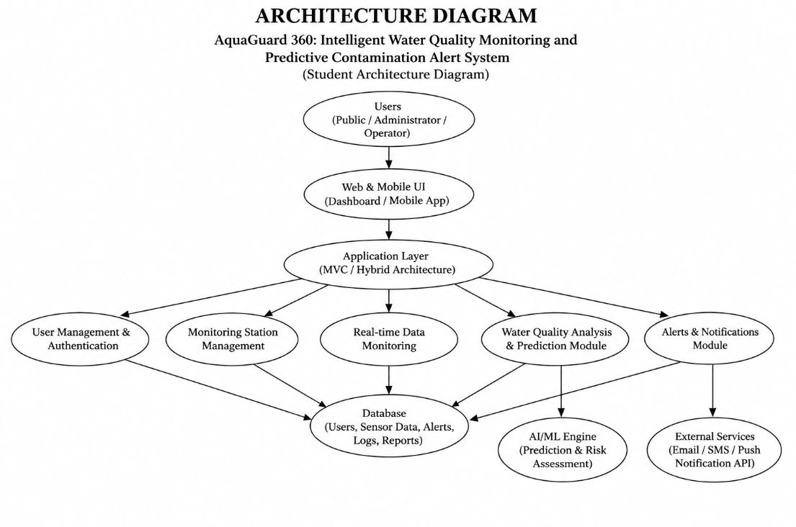

1. System Requirement Analysis
1.1 System Objectives
AquaGuard 360 is an intelligent water quality monitoring and predictive contamination alert system designed to help users continuously monitor water quality, collect data from water-quality sensors, analyze water parameters, detect abnormal conditions, predict potential contamination risks, and receive timely alerts. The system aims to provide accurate, secure, reliable, and accessible water-quality monitoring and predictive analysis.
1.2 Functional Requirements
- User registration and login
- User profile management
- Water-quality sensor data collection
- Real-time water-quality monitoring
- Monitoring of pH, turbidity, temperature, TDS, and other parameters
- Water-quality analysis and evaluation
- Predictive contamination analysis
- Contamination alerts and notifications
- Historical water-quality reports and analytics
- Feedback and system status monitoring
1.3 Non-Functional Requirements
- High availability
- Scalability for multiple monitoring stations
- Secure data storage
- Fast response time
- Reliability
- Maintainability
- User-friendly interface
1.4 Quality Attributes
- Scalability
- Security
- Performance
- Reliability
- Availability
- Maintainability
2. Selection of Software Architecture
Selected Architecture
Hybrid MVC Architecture
Justification
A Hybrid MVC Architecture is suitable because:
- Separates presentation, business logic, and data management.
- Simplifies maintenance and future enhancements.
- Supports web and mobile platforms.
- Allows integration with IoT sensors, AI/ML services, and external APIs.
- Provides better scalability and modular development.
3. Software Architecture Diagram
Insert the provided AquaGuard 360 architecture diagram image here.
Major Components
- Users
- Web and Mobile Interface
- Application Layer
- Authentication and User Management Module
- Monitoring Station Management Module
- Real-time Water Quality Monitoring Module
- Water Quality Analysis and Prediction Module
- Alerts and Notification Module
- Database
- AI/ML Engine
- External Services
4. Components and Their Interactions
4.1 User Interface Layer
Responsibilities:
- User interaction
- Dashboard display
- Water-quality monitoring display
- Historical data and report display
4.2 Authentication and User Management Module
Responsibilities:
- Registration
- Login
- Password management
- User authorization
- Role management
4.3 Monitoring Station Management Module
Responsibilities:
- Manage monitoring stations
- Manage connected sensors
- Monitor sensor status
- Configure monitoring parameters
4.4 Real-time Water Quality Monitoring Module
Responsibilities:
- Collect sensor data
- Monitor water-quality parameters
- Display real-time readings
- Detect abnormal water-quality values
4.5 Water Quality Analysis and Prediction Module
Responsibilities:
- Analyze water-quality data
- Compare readings with predefined thresholds
- Identify abnormal conditions
- Predict potential contamination risks
- Generate water-quality status
4.6 Alerts and Notification Module
Responsibilities:
- Contamination alerts
- Critical water-quality notifications
- Sensor failure notifications
- System notifications and reminders
4.7 Database
Stores:
- User information
- Sensor information
- Water-quality records
- Historical readings
- Alert records
- Prediction results
- Reports
4.8 AI/ML Engine
Responsibilities:
- Water-quality prediction
- Contamination risk analysis
- Pattern analysis
- Predictive alerts and recommendations
4.9 External Services
Responsibilities:
- Email notifications
- SMS alerts
- Push notifications
- External API services
System Workflow
- User logs into the AquaGuard 360 platform.
- Sensors collect water-quality parameters.
- Sensor data is transferred to the application.
- The system processes and analyzes water-quality data.
- Water-quality readings are stored in the database.
- The AI/ML engine analyzes patterns and predicts contamination risks.
- Alerts and notifications are generated when abnormal or critical conditions are detected.
- Reports are generated for monitoring water-quality trends and system performance.
5. Quality Attribute Evaluation
Scalability
- Modular architecture supports increasing numbers of monitoring stations and users.
- Database can be scaled independently.
- Additional sensors can be integrated in the future.
Security
- User authentication and authorization.
- Secure storage of water-quality and user data.
- Secure API communication.
- Access control for system users.
Performance
- Efficient database access.
- Fast processing of sensor readings.
- Optimized AI/ML prediction processing.
- Quick generation of contamination alerts.
Reliability
- Consistent water-quality monitoring.
- Sensor failure detection.
- Data backup and recovery mechanisms.
- Reliable alert generation.
Maintainability
- Modular design allows easier updates.
- Independent component management.
- New sensors and prediction features can be added without affecting the entire system.
Availability
- Continuous water-quality monitoring.
- Reliable access to the monitoring dashboard.
- Fault-tolerant deployment strategies.
- Continuous alert and notification services.
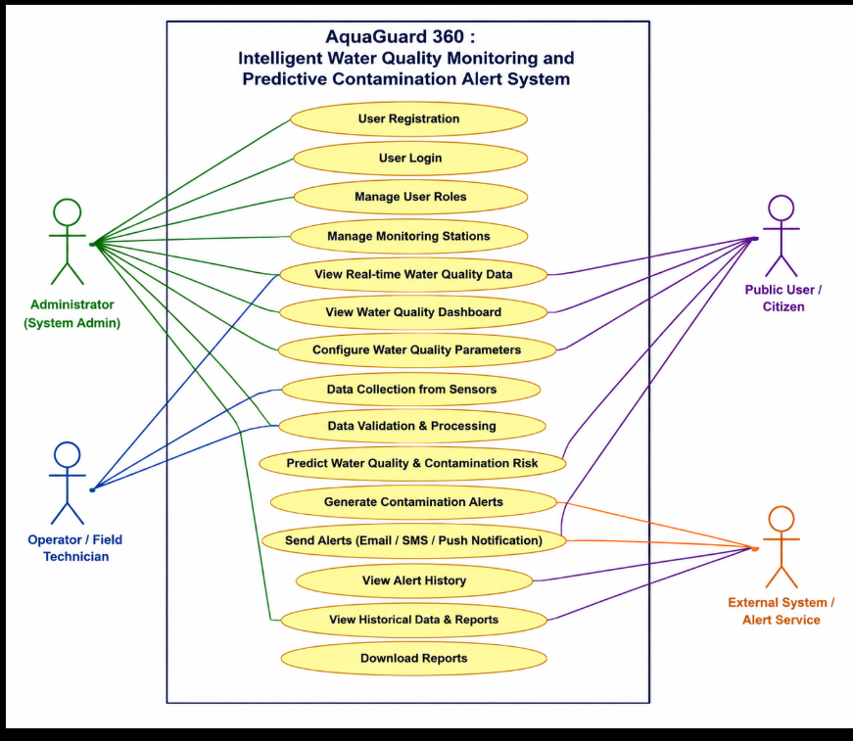

Justification of Architectural Decisions for AquaGuard 360
AquaGuard 360 is designed to provide intelligent water-quality monitoring through IoT-based sensor data collection, real-time water-quality analysis, predictive contamination detection, alerts, and historical reporting. Since the system continuously handles sensor data and may serve multiple monitoring stations and users, the architecture must be secure, scalable, reliable, and easy to maintain.
A Hybrid MVC Architecture was selected because it separates the application into different layers such as the user interface, business logic, and database layer. This separation helps developers manage the system efficiently and allows new monitoring and prediction features to be added without affecting existing functionalities.
The Real-Time Water Quality Monitoring Module is a core component of AquaGuard 360. It collects parameters such as pH, turbidity, temperature, TDS, and other water-quality readings from connected sensors. Real-time monitoring allows users to identify abnormal conditions quickly. However, continuous sensor data collection requires reliable communication, efficient processing, and proper data storage.
The Water Quality Analysis and Prediction Module analyzes collected sensor readings and identifies changes in water quality. The AI/ML engine can be used to identify patterns and predict possible contamination risks. This improves early detection and helps users take preventive action. The trade-off is that AI/ML processing requires additional computational resources and regular model maintenance.
The Monitoring Station Management Module allows administrators to manage monitoring stations and connected sensors. This makes it easier to monitor multiple locations and maintain sensor information. However, managing multiple sensors and stations increases system configuration and maintenance requirements.
An Alerts and Notification Service helps users receive timely warnings when water-quality parameters cross predefined thresholds or when potential contamination is predicted. This improves system responsiveness and safety. However, excessive alerts may reduce user satisfaction, so notification rules must be properly configured.
A Centralized Database is used to store user information, sensor information, water-quality readings, historical data, alerts, prediction results, and reports. This ensures data consistency and simplifies data management. However, database performance must be optimized as the amount of sensor data increases.
Since water-quality and user information should be protected, a strong Authentication and Authorization Module is required. User credentials and system data must be protected using secure authentication, authorization, and encryption techniques. Although these security measures increase system complexity, they are essential for protecting data.
External Services such as Email, SMS, and Push Notification APIs can be integrated into the system to provide contamination alerts and system notifications. These services improve communication and user convenience but create dependency on third-party service availability.

Future Enhancements
- Advanced AI-based contamination prediction
- Integration with additional IoT water-quality sensors
- Mobile application for real-time monitoring
- Automatic sensor calibration
- Geographic mapping of monitoring stations
- Advanced water-quality trend analytics
- Real-time cloud monitoring
- Automated maintenance alerts for faulty sensors

Architectural Decisions and Justification
Architectural Decision | Advantages | Disadvantages / Trade-Offs | Reason for Selection
Hybrid MVC Architecture | Clear separation of presentation, business logic, and data layers. Easy to understand and implement. | Slightly more complex than a simple monolithic design. | Suitable for handling multiple modules such as sensor monitoring, water-quality analysis, prediction, and alerts.
Centralized Database | Simplifies data management and reporting. Ensures consistency of sensor and user data. | Database can become a bottleneck if sensor data grows significantly. | Required for storing sensor readings, historical data, alerts, predictions, users, and reports.
AI/ML Engine Integration | Provides predictive contamination analysis and identifies water-quality patterns. Enhances the monitoring system. | Requires additional computational resources and AI model maintenance. | Core feature of AquaGuard 360 that enables predictive contamination detection.
Real-Time Monitoring Module | Provides continuous water-quality readings and helps detect abnormal conditions quickly. | Requires reliable sensor connectivity and continuous data processing. | Essential for monitoring pH, turbidity, temperature, TDS, and other water parameters.
Alerts and Notification Service | Improves response time through contamination warnings and system alerts. | Excessive notifications may reduce user satisfaction. | Necessary for informing users when unsafe or critical water-quality conditions are detected.
Monitoring Station Management Module | Allows administrators to manage multiple stations and connected sensors. | Requires additional configuration and maintenance as the number of sensors increases. | Supports monitoring of multiple water-quality locations.
API-Based External Services | Easy integration with Email, SMS, and Push Notification platforms. | Dependency on third-party service availability and pricing. | Supports scalable communication and timely contamination alerts.
Authentication and Authorization Module | Enhances security by restricting unauthorized access and protecting system information. | Additional development effort for secure implementation. | Required to protect user accounts, monitoring data, and administrative functions.
Water Quality Analysis and Prediction Module | Helps identify abnormal readings and predict potential contamination risks. | Requires efficient data processing and continuous model improvement. | Essential for converting raw sensor data into useful water-quality insights.
Modular Component Design | Components can be updated independently and improve maintainability. | Increased coordination may be required between modules. | Supports future enhancements without affecting the entire system.
Cloud Deployment Support | Provides high availability and scalability. Enables remote access to monitoring data. | Cloud infrastructure may increase operational costs. | Suitable for supporting a growing number of users, sensors, and monitoring stations.

Conclusion
The proposed Hybrid MVC Architecture for AquaGuard 360 provides a scalable, secure, reliable, and maintainable solution for intelligent water-quality monitoring. The architecture effectively integrates IoT sensor monitoring, water-quality analysis, AI/ML-based contamination prediction, alerts and notifications, centralized data storage, and reporting while supporting future growth and system enhancements. The modular architecture also allows new sensors, analytical features, and monitoring capabilities to be added without significantly affecting the existing system.

